**FCar**

**Software Requirement Specification**

**Software Design Document**

**Made by: TeamDev**

### **Group Member**

**- Dương Tuấn Kiệt - SE151418**

**- Lê Thanh Danh - SE161278**

**- Phan Đức Đạt - SE150689**

**- Ngô Tấn Lợi - SE151426**

**- Liêng Khánh Duy - SE161102**

**- Nguyễn Ngọc Kiều Thơ - SE161254**

## Table Of Contents

Group Member 1

Table Of Contents 1

**I Overview 3**

1. Project Information 4

2.Introduction 4

3. System Functions 4

a. Use case Diagram 4

b. State Diagram 5

c. User Authorization 6

d. Non-Screen Functions 7

**II. Functional Requirements 9**

1. Page access 9

a. Sign In 9

UC1 - Sign in 9

Activity diagram 10

Sequence diagram 11

b. Sign Up 11

UC2 - Sign up 11

Activity diagram 12

Sequence diagram 13

c. Change Password 13

UC3 - Change password 13

Activity diagram 14

Sequence diagram 14

2. Product operations 14

a. View Product List 15

UC4 - View Product List 15

Activity diagram 16

Sequence diagram 16

b. Add Product 16

UC5 - Add a product 16

Activity diagram 18

Sequence diagram 18

c. Update Product 18

UC 6-Update a product 18

Activity diagram 20

Sequence diagram 20

d. Delete Product 20

UC 7-Delete a Product 20

Activity diagram 21

Sequence diagram 22

3. Brands operations 22

a. View Brands list 22

UC8 - View Brand List 22

Activity diagram 23

Sequence diagram 23

b. Add Brand 23

UC9- Add a brand 24

Activity diagram 25

Sequence diagram 25

c. Update Brand 25

UC10-Update a brand 25

Activity diagram 27

Sequence diagram 27

d. Delete Brand 27

UC11 - Delete a Product 27

Activity diagram 28

Sequence diagram 29

4. Manager User(Admin) 29

a. View Customer Account list: 29

UC12 - View Customer Account List 29

Activity diagram 30

Sequence diagram 31

b. View Staff Account list: 31

UC13 - View Staff Account List 31

Activity diagram 32

Sequence diagram 32

c. Change status 32

UC14 - Change staff account status 33

Activity diagram 34

Sequence diagram 34

5. Profile 34

a. Show profile 35

UC15 - View Profile 35

Activity diagram 36

Sequence diagram 36

b. Update profile 37

UC16 - Update Profile 37

Activity diagram 37

Sequence diagram 38

6. Order 38

a. Order History 38

UC17 - View Order History 38

Activity diagram 39

Sequence diagram 39

b. Order detail 39

UC 18 - View Order Detail 39

Activity diagram 40

Sequence diagram 40

c. Proceed order for staff 41

UC15 - Proceed Order 41

Activity diagram 42

Sequence diagram 42

**III. Database 42**

1. ERD: 42

2. Database table: 43

# **I Overview**

## **1. Project Information**

· Project name:  **FCar - FPT Shop**

· Project Code: **FC**

· Product Type: **Website Application**

· Start Date: **May 20th, 2023**

· End Date:**July 20th, 2023**

. Background: People find it hard to get a good car for themselve. This website works as an online showroom. Provide a more convenient solution for customers wishing to buy or view a car.

## **2**.**Introduction**

This document describes the functional and non-functional requirements for the software release 1.0 of the FCar. This document is intended for use by members of the project team who will implement and test the system's functionality. Unless otherwise stated, all requirements outlined in this document are committed for release 1.0.

This Website was created to provide clients with a user-friendly and engaging online platform for browsing and purchasing cars and related products.

## **3. System Functions**

#### ***a. Use case Diagram***

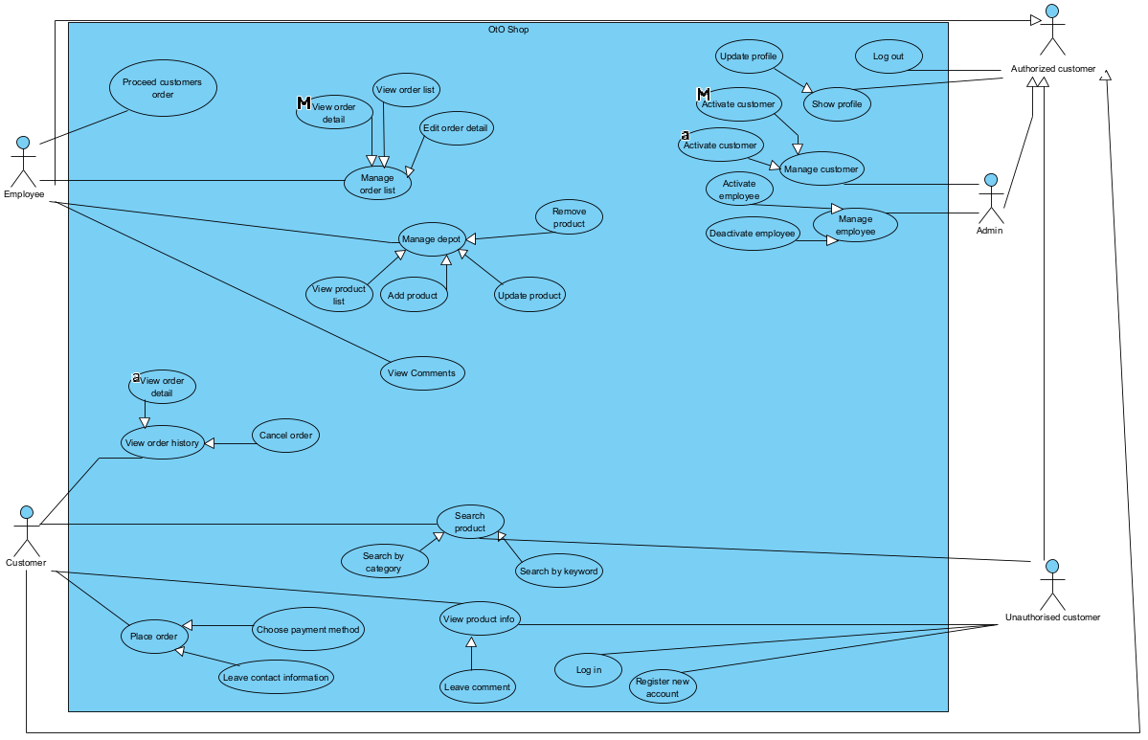

#### ***b. State Diagram***

* State diagram for user:

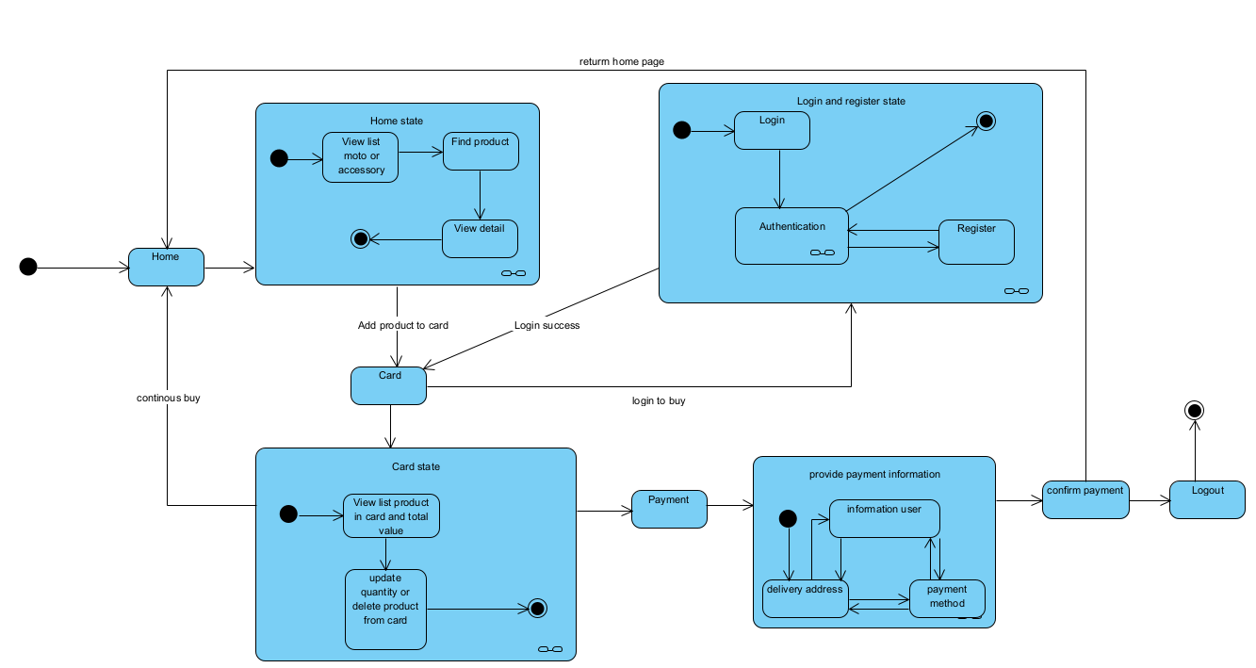

* State Diagram for admin:

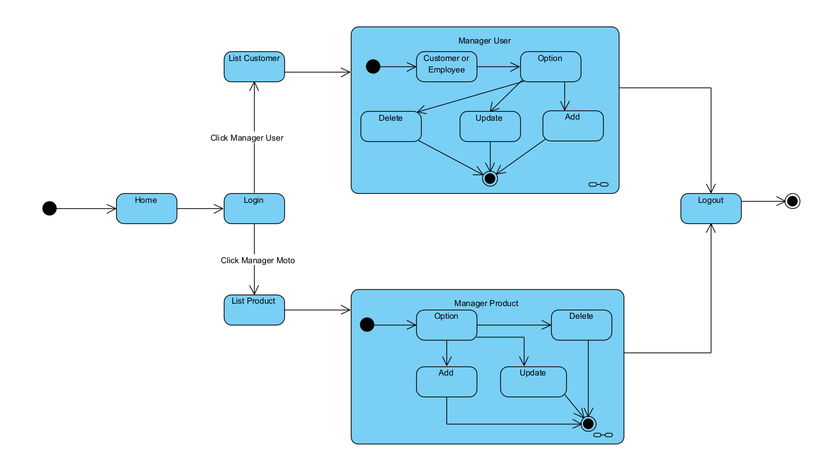

#### ***c. User Authorization***

| **Screen** | **Admin** | **Employee** | **Customer** |
| --- | --- | --- | --- |
| Home page | X | X | X |
| View Product list | X | X | X |
| Search bar | X | X | X |
| Product page | X | X | X |
| View product detail | X | X | X |
| Profile page | X | X | X |
| Management page | X | X |  |
| Query All Data | X | X |  |
| Query Own Data | X | X |  |
| Query Managed Data | X | X |  |
| Add New Data | X |  |  |
| Update All Data | X |  |  |
| Update Own Data | X | X |  |
| Update Managed Data | X |  |  |
| Delete Data | X | X |  |

In which:

· Role Amin: Admin of the page, can manage account

· Role Employee: Can access own Data, product Data and Order Data, manage product, manage data

· Role Customer: Can access own Data, view Product Data, make Order and view Order Data

#### ***d. Non-Screen Functions***

| **#** | **Feature** | **System Function** | **Description** |
| --- | --- | --- | --- |
| 1 | Login | Login | User login to access more resource |
| 2 | Signup | Signup | User can sign up to login |
| 3 | Logout | Home (already login) | User can logout to end session |
| 4 | Home | Home | User can see car or menu |
| 5 | Show profile | Profile detail | User can view their own profile |
| 6 | Update profile | Popup update profile | User can update their own information |
| 7 | Change pass | Popup change pass | User can change their password |
| 8 | History order | History order | User can see all order history |
| 9 | Order detail | Order detail | User can see detail of each their order |
| 10 | Product detail | Product detail | User can see detail each product when click this product |
| 11 | Order manager | Order manager | Admin can manager order customer and order detail such as: see all, delete, change status but not update |
| 12 | Customer manager | Customer manager | Admin can manager customer and staff |
| 13 | Product manager | Product manager | Admin and staff can manager product |
| 14 | Show list user | List user | Admin can see all user |
| 15 | Show list product | List product | Admin and staff can see list product |

# **II. Functional Requirements**

## **1. Page access**

### **a. Sign In**

| **ID and Name:** | UC1 - Sign in | | |
| --- | --- | --- | --- |
| **Created By:** | TeamDev | **Date Created:** | **10/06/23** |
| **Primary Actor:** | Unauthorised user | Secondary Actors: | N/A |
| **Description:** | Actor wants to Sign in website with his account | | |
| **Trigger:** | - Users are able to access the login form of website  - Actor clicks on the Login button. | | |
| **Pre-Conditions:** | Actors have access to the system and have a pre-created account. | | |
| **Post-Conditions:** | Member is authorised and gets access to the respective tasks  Member will be redirected to Home screen | | |
| **Normal Flow:** | 1.Guest accesses the HRMS and be redirected to Home screen  2. Guest taps on “Login” link in Navigation bar  3. Display Login screen that has Login form  4. Guest fills in email and password  5. Guest taps on “Login” button | | |
| **Alternative Flows:** | 1.a User clicks on the Order button in Product detail page  1.b Return to step 3 in normal flow  2.a User clicks on the Order button in home page, at the product  2.b Return to step 3 in normal flow | | |
| **Exceptions:** | Guest inputs wrong email and password  Guest does not remember password | | |
| **Priority:** | High | | |
| **Frequency of Use:** | When user want to make an authorised-required action like make an order | | |
| **Business Rules:** | N/A | | |
| **Other Information:** | N/A | | |
| **Assumptions:** | N/A | | |

* Function trigger: When the user click button login or customer want to buy accessory or reserve car
* Function description: This page allow user to login into the system
* Screen layout:
* Function detail: Users can login into the system to access more resources, more pages, more action.

#### Activity diagram

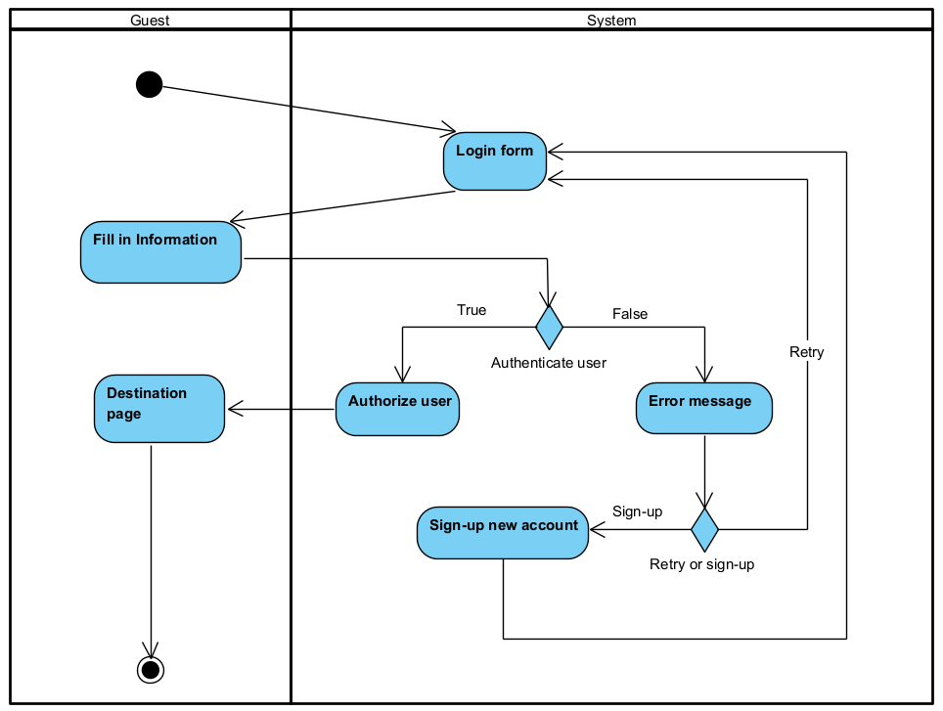

#### Sequence diagram

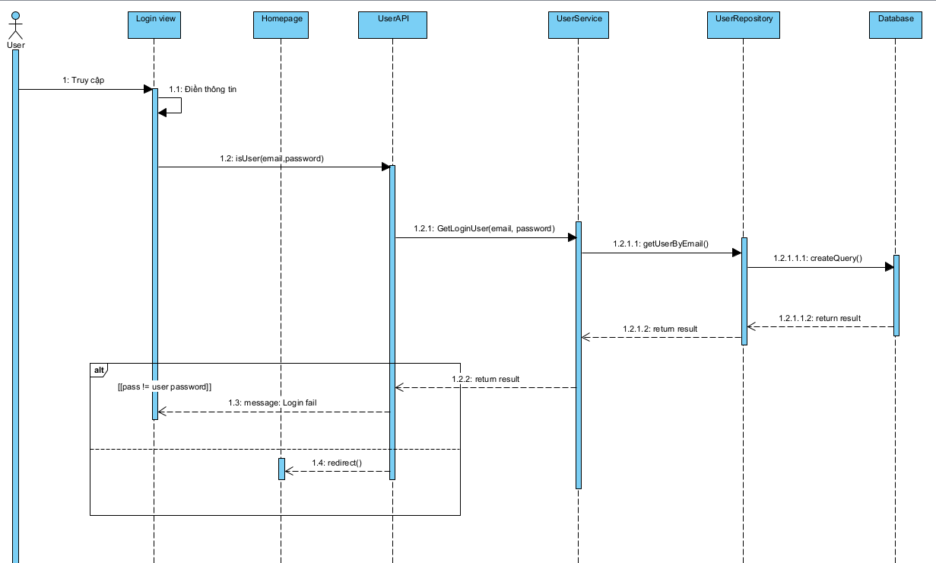

### **b. Sign Up**

| ID and Name: | UC2 - Sign up | | |
| --- | --- | --- | --- |
| Created By: | TeamDev | Date Created: | 10/06/2023 |
| Primary Actor: | Unauthorised user - Guest | Secondary Actors: | N/A |
| Description: | Guest sign up for an account in system | | |
| Trigger: | Guest wants to sign up for an account | | |
| Preconditions: | Guest has an email | | |
| Postconditions: | Guest is registered and become a member  Guest will be redirected to Home screen | | |
| Normal Flow: | 1. Guest entered the FC  2. Guest taps on “Register” link in Navigation bar  3. System shows the Register screen that has Register form  3. Guest fills in information  4. Guest taps on “Register” button | | |
| Alternative Flows: | 1.a User clicks the “Register” button in the “Login” screen.  1.b Return to step 3 in normal flow. | | |
| Exceptions: | Guest fills in invalid information  Guest has an account already | | |
| Priority: | High | | |
| Frequency of Use: | Approximately 500 users, average of one usage per day. | | |
| Business Rules: | N/A | | |
| Other Information: | N/A | | |
| Assumptions: | N/A | | |

### 

* Function trigger: After guest click button sign up into login page
* Function description: This page allow guest to register account when use into the system
* Screen layout:
* Function detail: user can create their own new account if the account with email not exist in the system

#### Activity diagram

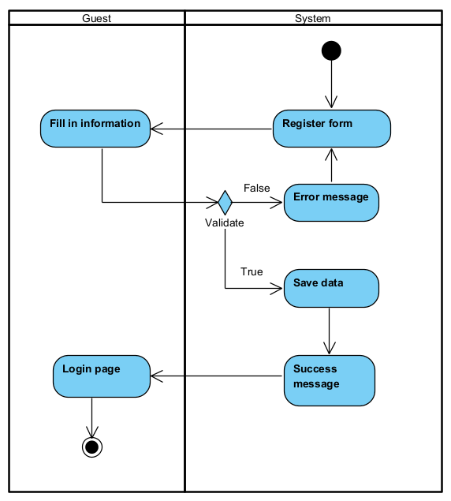

#### Sequence diagram

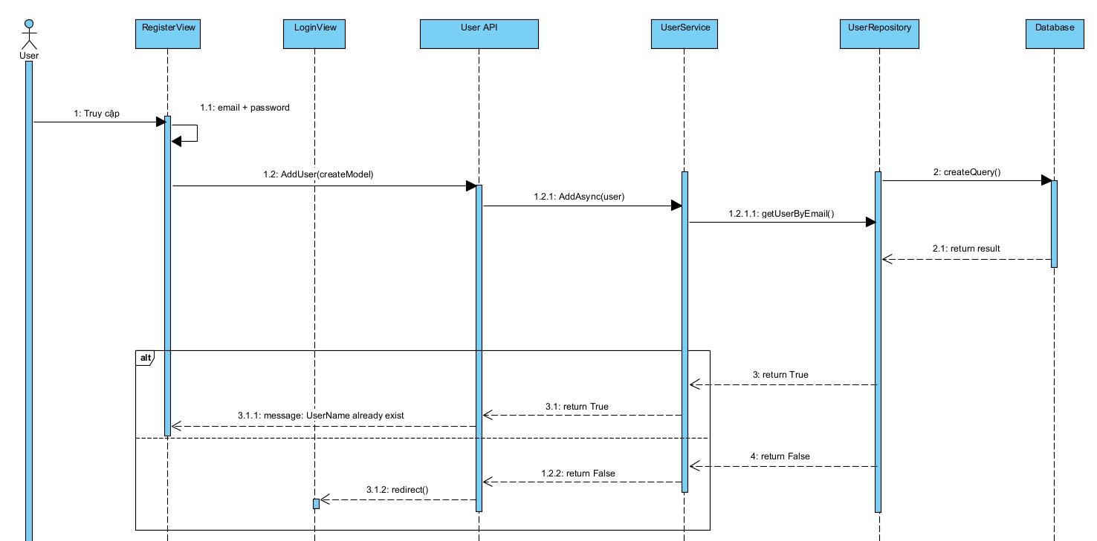

### **c. Change Password**

| ID and Name: | UC3 - Change password | | |
| --- | --- | --- | --- |
| Created By: | TeamDev | Date Created: | 30/06/2023 |
| Primary Actor: | Authorised User | Secondary Actors: | Human Resource Management System |
| Description: | This feature allows user to change password | | |
| Trigger: | User indicates that they want to edit their profile | | |
| Preconditions: | User has logged in successfully | | |
| Postconditions: | New user password is updated in the system | | |
| Normal Flow: | User clicks on “Change password” button  User fill Old password  User fill New password  User confirm New password  User clicks on Change password button  System displays result message | | |
| Alternative Flows: | User click to the previous page or “Cancel” before change  Password still remain unchanged | | |
| Exceptions: | User escape Update Profile screen before select “Change password”  User fill invalid password | | |
| Priority: | High | | |
| Frequency of Use: | Usually | | |
| Business Rules: | N/A | | |
| Other Information: | N/A | | |
| Assumptions: | N/A | | |

* Function trigger: After user click on change password link in login page, signup page or change when login into user profile
* Function description: This page allow user to change their password account
* Screen layout:
* Function detail: user must login into system or all input must require before change password

#### Activity diagram

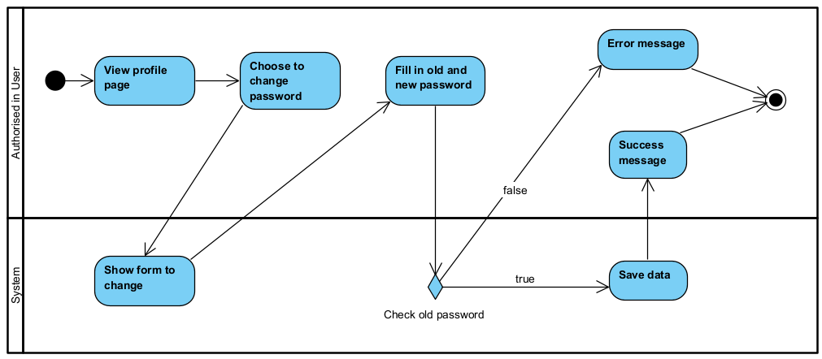

#### Sequence diagram

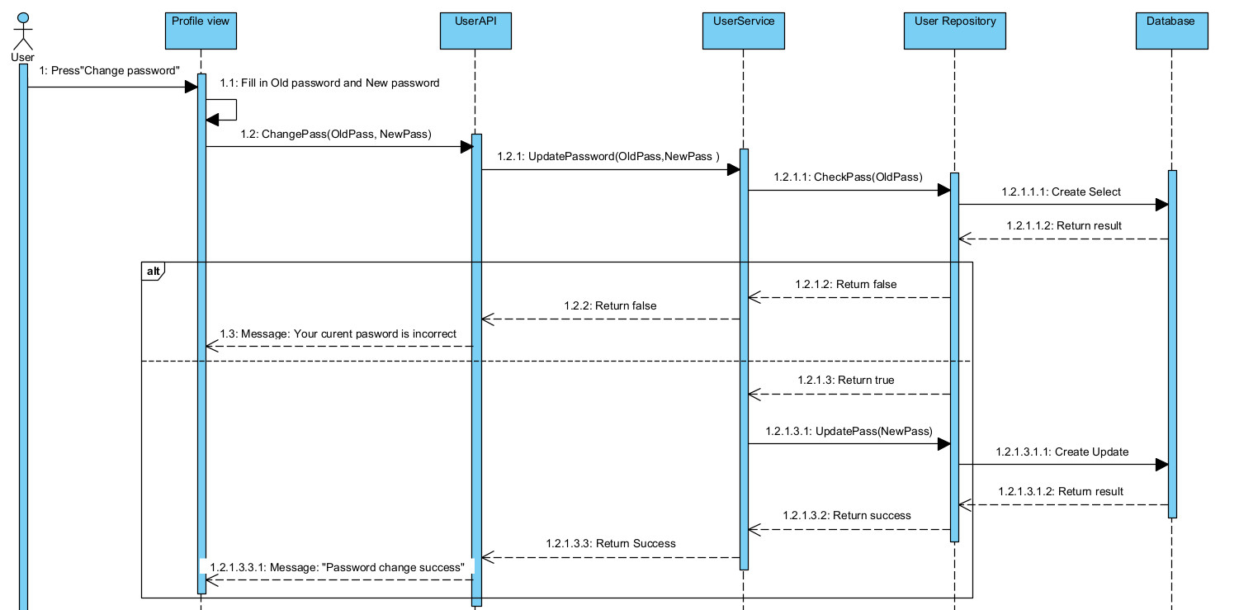

## **2. Product operations**

### View Product List

| ID and Name: | UC4 - View Product List | | |
| --- | --- | --- | --- |
| Created By: | TeamDev | Date Created: | 30/06/2023 |
| Primary Actor: | Admin, staff | Secondary Actors: | Staff |
| Description: | Admin, staff want to see product list | | |
| Trigger: | Click link manager product | | |
| Preconditions: | Admin/staff access into Manager page | | |
| Postconditions: | N/A | | |
| Normal Flow: | Actor choose “Manage product” in Manager page  System show product list | | |
| Alternative Flows: | N/A | | |
| Exceptions: | N/A | | |
| Priority: | High | | |
| Frequency of Use: | Usually | | |
| Business Rules: | N/A | | |
| Other Information: | N/A | | |
| Assumptions: | N/A | | |

* Function trigger: After admin or staff click link manager product
* Function description: This page allow admin or staff to seen their product
* Screen layout:
* Function detail: user must login with admin or staff role before do this action to view all product

#### Activity diagram

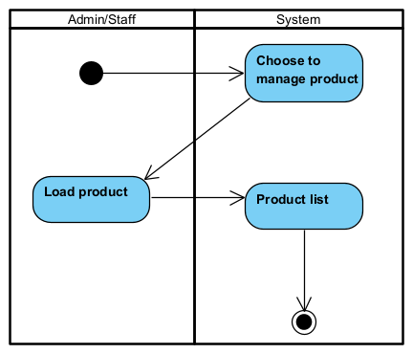

#### Sequence diagram

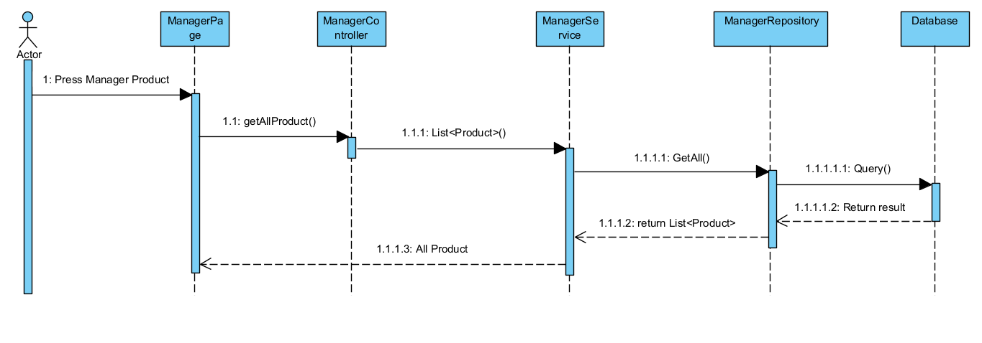

### Add Product

### 

| **ID and Name:** | UC5 - Add a product | | |
| --- | --- | --- | --- |
| **Created By:** | TeamDev | **Date Created:** | **30/06/2023** |
| **Primary Actor:** | Admin, Staff | Secondary Actors: | N/A |
| **Description:** | Actor wants to add a new product for the website. | | |
| **Trigger:** | - Users access into Manager page  - Actor clicks “Add product” to create a new product. | | |
| **Pre-Conditions:** | Actors have access to the system into the Manager page. | | |
| **Post-Conditions:** | New product is stored in the back-end with suitable status.  New product has a full description and status. | | |
| **Normal Flow:** | Create a product for application:  1. Actor signs in the system.  2. Actor chooses to see the product list then.  3. Actor chooses to add a new product.  4. System then show the adding form  5. Actor then fills in product information .  6. Actor clicks the Add button.  8. Actor is redirected back to manager page with updated Product list | | |
| **Alternative Flows:** | N/A | | |
| **Exceptions:** | The product has just entered the system and has the same data with other products in the same category. | | |
| **Priority:** | High | | |
| **Frequency of Use:** | Usually | | |
| **Business Rules:** | N/A | | |
| **Other Information:** | 1. The Actor can cancel the "Add product" process at any time prior to confirming it.  2. Any product must belong to a category. | | |
| **Assumptions:** | Internet connection is available. | | |

* Function trigger: After admin or staff click link manager product and click create product button
* Function description: This page allow admin or staff to create their product
* Screen layout:
* Function detail: user must login with admin or staff role before do this action to create product

#### Activity diagram

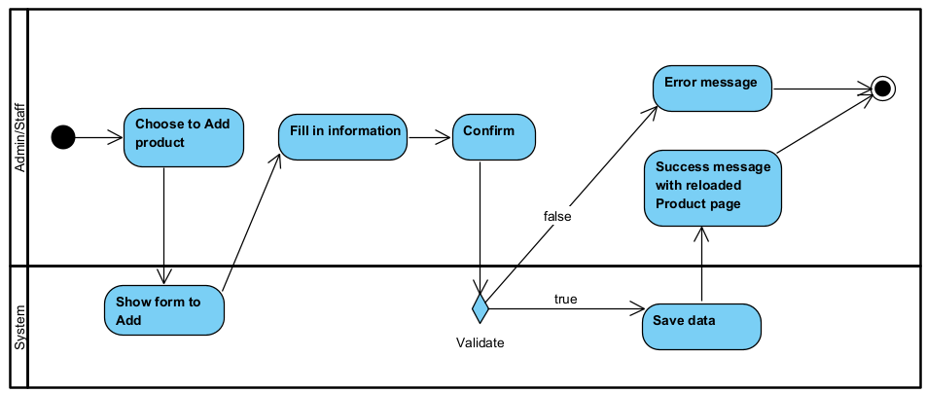

#### Sequence diagram

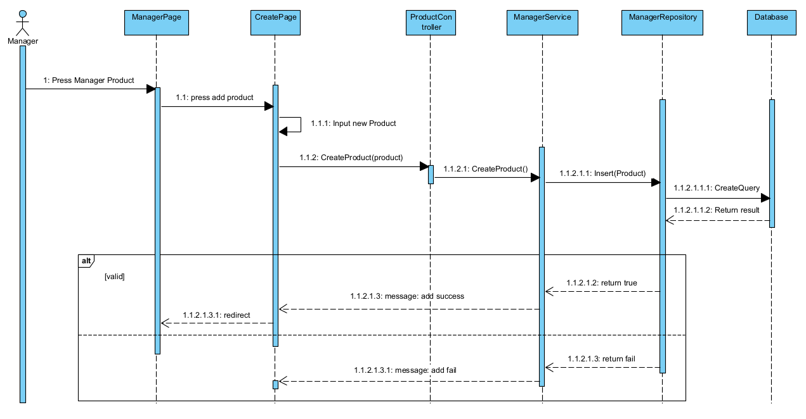

### Update Product

| **ID and Name:** | UC 6-Update a product | | |
| --- | --- | --- | --- |
| **Created By:** | TeamDev | **Date Created:** | **10/06/2023** |
| **Primary Actor:** | Admin, Staff | Secondary Actors: | N/A |
| **Description:** | Actor wants to modify the product for application. | | |
| **Trigger:** | - Users are able to access the system in the Manager page.  - Actors choose a product to update | | |
| **Pre-Conditions:** | Actors have access to the system. | | |
| **Post-Conditions:** | New data of modified product is updated in database | | |
| **Normal Flow:** | Staff signs in the system.  Staff click into a product on list  Staff then get product in detail  Staff then change the desired information about product  Staff click “Update” | | |
| **Alternative Flows:** | Staff clicks the "Back to list" button.  a. Update request is destroyed.  b. Information about this project is maintained. | | |
| **Exceptions:** | N/A | | |
| **Priority:** | High | | |
| **Frequency of Use:** | The beginning of each quarter of the year (January, April, July, October) when the showroom needs to update information. Or when product information need to be adjusted | | |
| **Business Rules:** | N/A | | |
| **Other Information:** | N/A | | |
| **Assumptions:** | Internet connection is available. | | |

### 

* Function trigger: After admin or staff click link manager product and click update product button per product
* Function description: This page allow admin or staff to update their product
* Screen layout:
* Function detail: user must login with admin or staff role before do this action to update product

#### Activity diagram

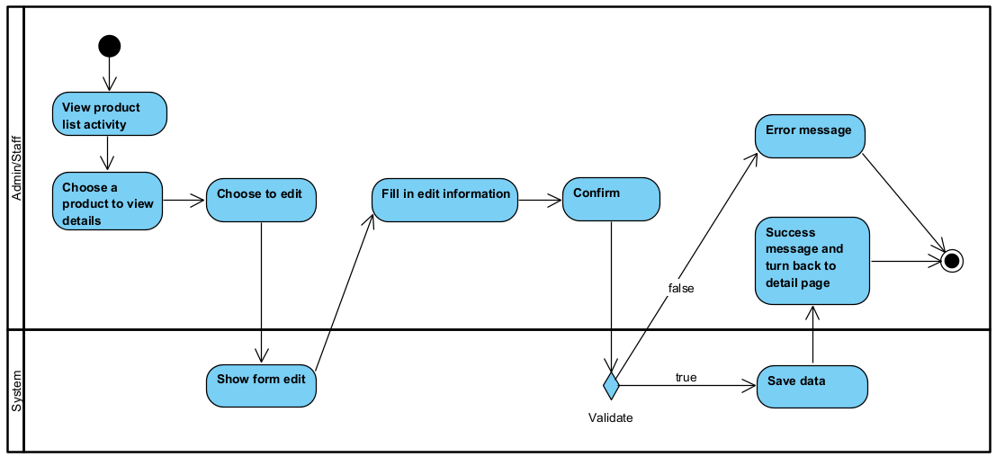

#### Sequence diagram

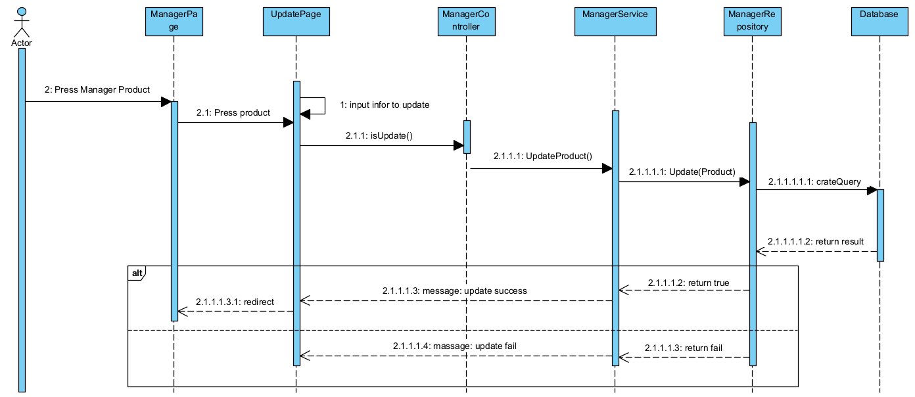

### Delete Product

| **ID and Name:** | UC 7-Delete a Product | | |
| --- | --- | --- | --- |
| **Created By:** | TeamDev | **Date Created:** | **30/06/2023** |
| **Primary Actor:** | Admin, Staff | Secondary Actors: | N/A |
| **Description:** | Actor wants to delete a product | | |
| **Trigger:** | - Users are able to access the system into the Manager page.  - Actors choose a product for updating. | | |
| **Pre-Conditions:** | Actors have access to the system. | | |
| **Post-Conditions:** | Product is stored in the back-end with suitable status. | | |
| **Normal Flow:** | Staff signs in the system.  Staff choose the desire product  Staff get into product detail  Staff then clicks “Delete”  A pop up appear to confirm action  Staff choose action (confirm)  Staff gets redirected back to Manager page with Updated list | | |
| **Alternative Flows:** | HR Manager clicks "Cancel" button  a. Update request is destroyed.  b. Information about this product is maintained.  c. Product list show unchanged | | |
| **Exceptions:** | N/A | | |
| **Priority:** | High | | |
| **Frequency of Use:** | When Showroom do not want to sell the specific product anymore | | |
| **Business Rules:** | N/A | | |
| **Other Information:** | N/A | | |
| **Assumptions:** | Internet connection is available. | | |

### 

* Function trigger: After admin or staff click link manager product and click delete product button per product
* Function description: This page allow admin or staff to delete their product
* Screen layout:
* Function detail: user must login with admin or staff role before do this action to delete product if product have into order just change status

#### Activity diagram

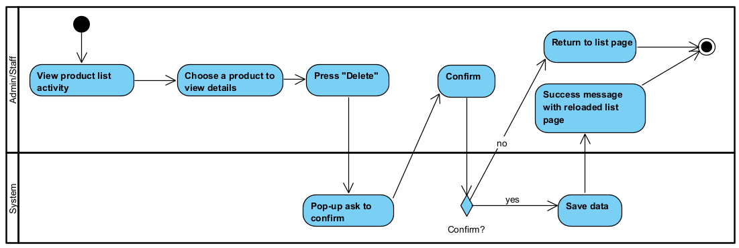

#### Sequence diagram

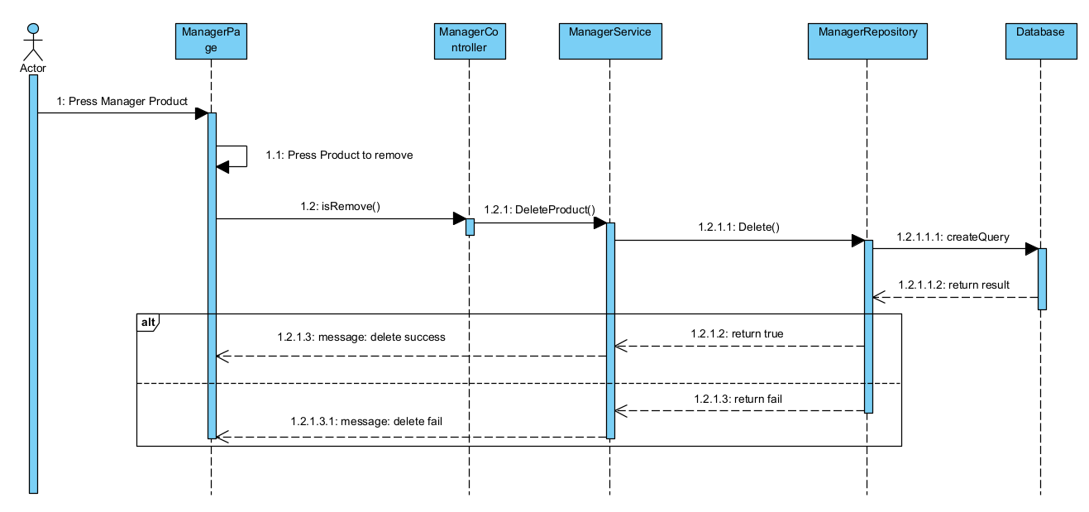

**================================================**

## **3. Brands operations**

### View Brands list

| ID and Name: | UC8 - View Brand List | | |
| --- | --- | --- | --- |
| Created By: | TeamDev | Date Created: | 30/06/2023 |
| Primary Actor: | Unauthorised User, Authorised User | Secondary Actors: | Staff |
| Description: | User want to see brand list | | |
| Trigger: | Click link Brand list | | |
| Preconditions: | User access into Home page | | |
| Postconditions: | N/A | | |
| Normal Flow: | Actor choose “List Brands” in Home page  System show brand list | | |
| Alternative Flows: | N/A | | |
| Exceptions: | N/A | | |
| Priority: | High | | |
| Frequency of Use: | Usually | | |
| Business Rules: | N/A | | |
| Other Information: | N/A | | |
| Assumptions: | N/A | | |

* Function trigger: After User click link
* Function description: This page allow admin or staff to seen their product
* Screen layout:
* Function detail: Every user is able to do this action to view all product

#### Activity diagram

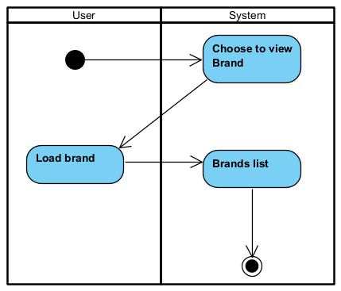

#### Sequence diagram

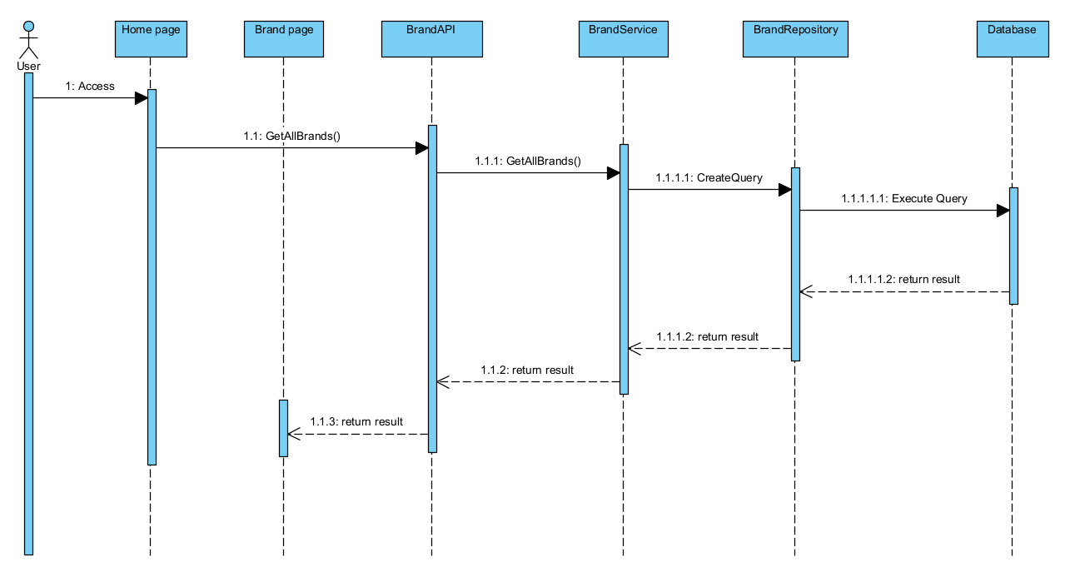

### Add Brand

### 

| **ID and Name:** | UC9- Add a brand | | |
| --- | --- | --- | --- |
| **Created By:** | TeamDev | **Date Created:** | **30/06/2023** |
| **Primary Actor:** | Admin, Staff | Secondary Actors: | N/A |
| **Description:** | Actor wants to add a new brand for the website. | | |
| **Trigger:** | - Users access into Manager page  - Actor clicks “Add Brand” to create a new product. | | |
| **Pre-Conditions:** | Actors have access to the system into the Manager page. | | |
| **Post-Conditions:** | New product is stored in the back-end with suitable status.  New product has a full description and status. | | |
| **Normal Flow:** | Create a product for application:  1. Actor signs in the system.  2. Actor chooses to see the brand list then.  3. Actor chooses to add a new brand.  4. System then show the adding form  5. Actor then fills in brand information .  6. Actor clicks the Add button.  8. Actor is redirected back to manager page with updated Brand list | | |
| **Alternative Flows:** | N/A | | |
| **Exceptions:** | The product has just entered the system and has the same data with other products in the same category. | | |
| **Priority:** | High | | |
| **Frequency of Use:** | Usually | | |
| **Business Rules:** | N/A | | |
| **Other Information:** | 1. The Actor can cancel the "Add product" process at any time prior to confirming it.  2. Any product must belong to a category. | | |
| **Assumptions:** | Internet connection is available. | | |

* Function trigger: After admin or staff click link manager brand and click create product button
* Function description: This page allow admin or staff to create their brand
* Screen layout:
* Function detail: User must login with admin or staff role before do this action to create product

#### Activity diagram

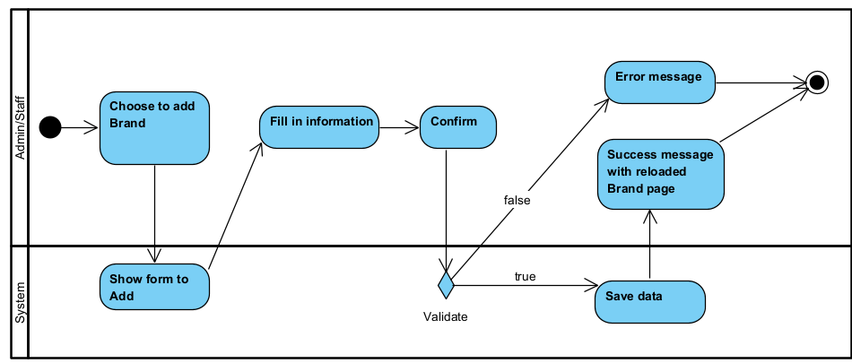

#### Sequence diagram

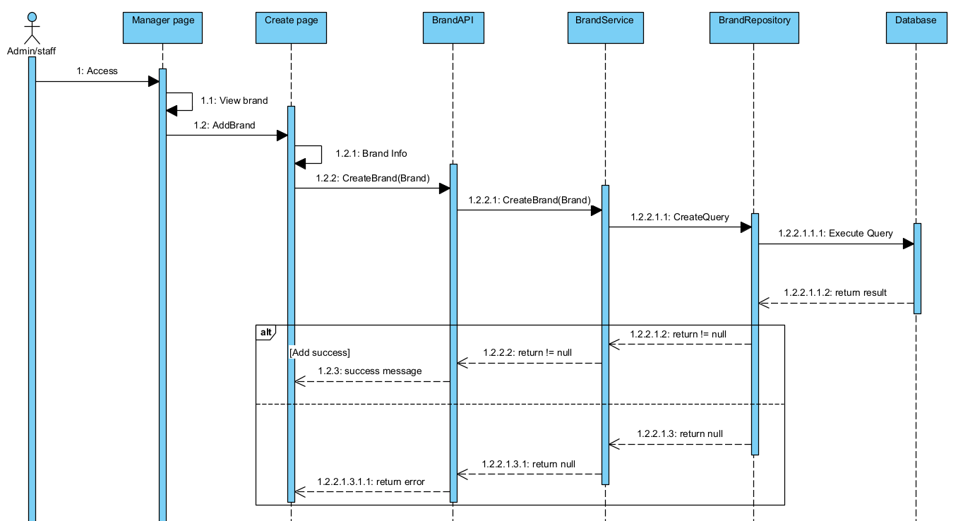

### Update Brand

| **ID and Name:** | UC10-Update a brand | | |
| --- | --- | --- | --- |
| **Created By:** | TeamDev | **Date Created:** | **10/06/2023** |
| **Primary Actor:** | Admin, Staff | Secondary Actors: | N/A |
| **Description:** | Actor wants to modify the brand for application. | | |
| **Trigger:** | - Users are able to access the system in the Manager page.  - Actors choose a brand to update | | |
| **Pre-Conditions:** | Actors have access to the system. | | |
| **Post-Conditions:** | New data of modified brand is updated in database | | |
| **Normal Flow:** | Staff signs in the system.  Staff click into a brand on list  Staff then get brand in detail  Staff then change the desired information about brand  Staff click “Update” | | |
| **Alternative Flows:** | Staff clicks the "Back to list" button.  a. Update request is destroyed.  b. Information about this project is maintained. | | |
| **Exceptions:** | N/A | | |
| **Priority:** | High | | |
| **Frequency of Use:** | The beginning of each quarter of the year (January, April, July, October) when the showroom needs to update information. Or when brand information need to be adjusted | | |
| **Business Rules:** | N/A | | |
| **Other Information:** | N/A | | |
| **Assumptions:** | Internet connection is available. | | |

### 

* Function trigger: After admin or staff click link manager brand and click update product button per brand
* Function description: This page allow admin or staff to update car brands
* Screen layout:
* Function detail: User must login with admin or staff role before do this action to update brand

#### Activity diagram

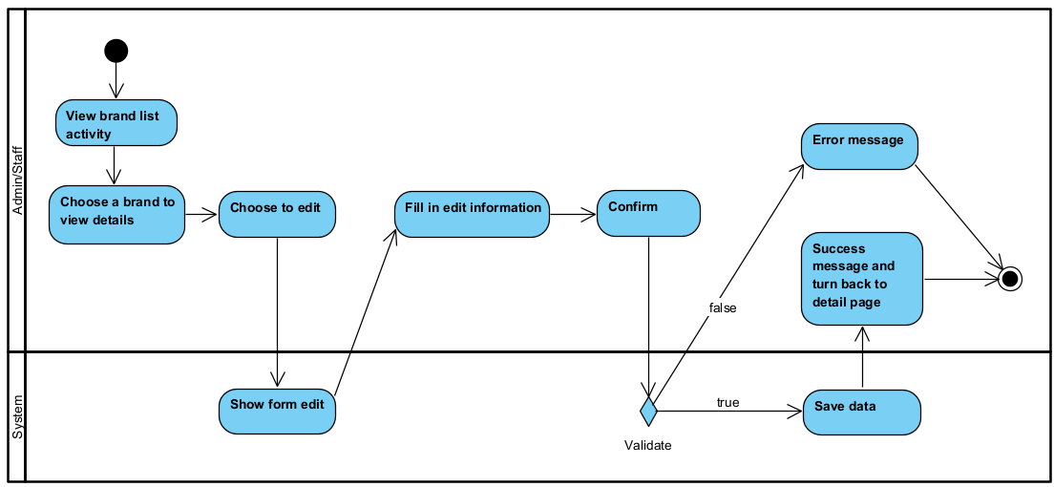

#### Sequence diagram

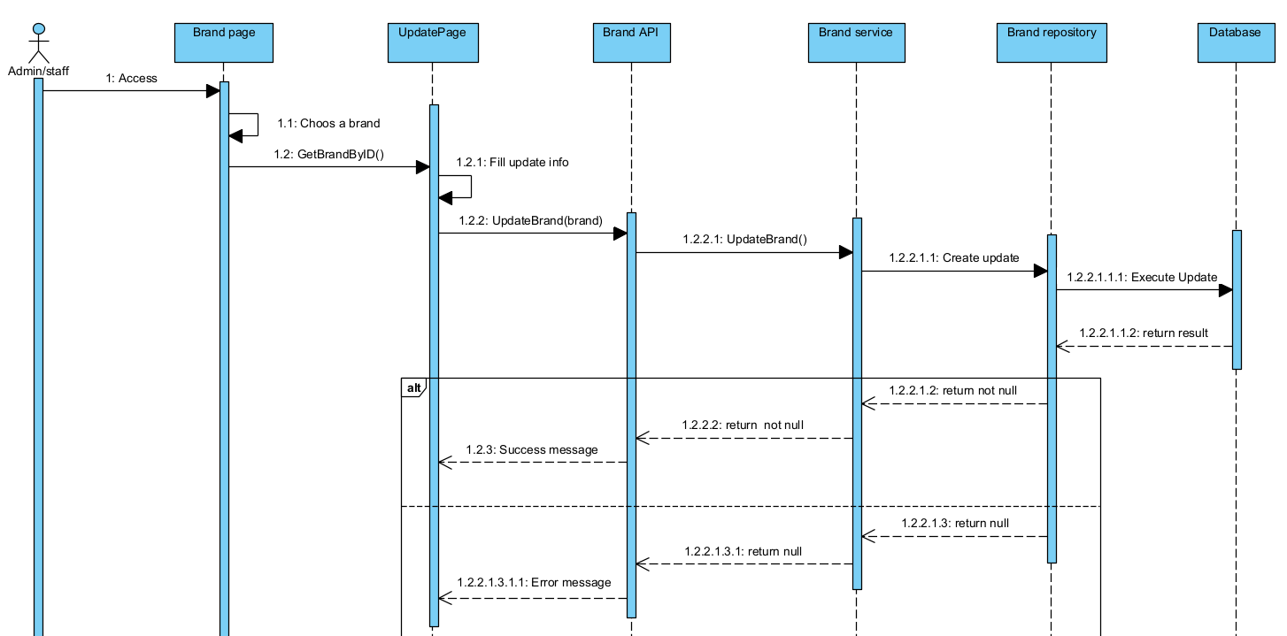

### Delete Brand

| **ID and Name:** | UC11 - Delete a Product | | |
| --- | --- | --- | --- |
| **Created By:** | TeamDev | **Date Created:** | **30/06/2023** |
| **Primary Actor:** | Admin, Staff | Secondary Actors: | N/A |
| **Description:** | Actor wants to delete a brand | | |
| **Trigger:** | - Users are able to access the system into the Manager page.  - Actors choose a brand for updating. | | |
| **Pre-Conditions:** | Actors have access to the system. | | |
| **Post-Conditions:** | Brand is stored in the back-end with suitable status. | | |
| **Normal Flow:** | Staff signs in the system.  Staff choose the desire brand  Staff get into product detail  Staff then clicks “Delete”  A pop up appear to confirm action  Staff choose action (confirm)  Staff gets redirected back to Brand page with updated list | | |
| **Alternative Flows:** | User clicks "Cancel" button  a. Update request is destroyed.  b. Information about this brand is maintained.  c. Product list show unchanged | | |
| **Exceptions:** | N/A | | |
| **Priority:** | High | | |
| **Frequency of Use:** | When Showroom do not want to sell the specific car brand anymore | | |
| **Business Rules:** | N/A | | |
| **Other Information:** | N/A | | |
| **Assumptions:** | Internet connection is available. | | |

### 

* Function trigger: After admin or staff click link manager brand and click delete product button per product
* Function description: This page allow admin or staff to delete their brand
* Screen layout:
* Function detail: User must login with admin or staff role before do this action to delete brand if product have into order just change status

#### Activity diagram

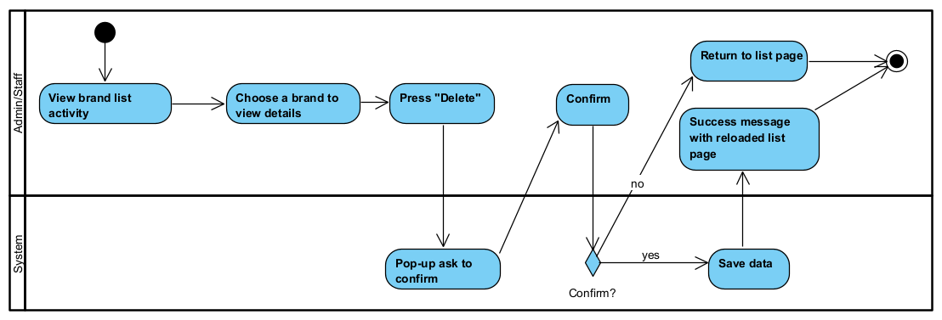

#### Sequence diagram

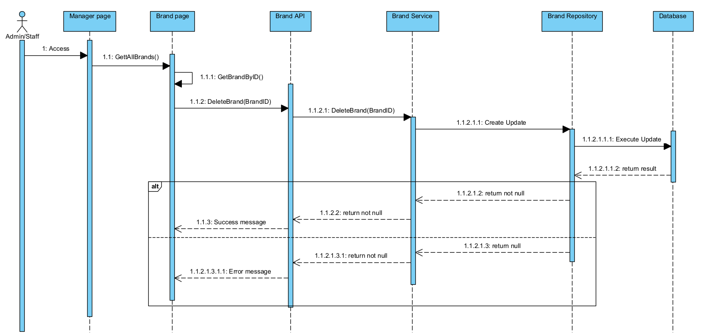

## **4. Manager User(Admin)**

### View Customer Account list:

| ID and Name: | UC12 - View Customer Account List | | |
| --- | --- | --- | --- |
| Created By: | TeamDev | Date Created: | 30/06/2023 |
| Primary Actor: | Admin | Secondary Actors: | FC |
| Description: | This feature allows Admin to view Customer Account list | | |
| Trigger: | Admin indicates that he wants to view Customer account list in his showroom | | |
| Preconditions: | User has logged in successfully  User access in Manager page | | |
| Postconditions: |  | | |
| Normal Flow: | 1. User tap on "User management" in the Manager page  2. System displays User account list | | |
| Alternative Flows: | N/A | | |
| Exceptions: | Admin want to see Account list but it is empty or can not be show | | |
| Priority: | Low | | |
| Frequency of Use: | Usually | | |
| Business Rules: | N/A | | |
| Other Information: | N/A | | |
| Assumptions: | N/A | | |

* Function trigger: After admin click link manager user
* Function description: This page allow admin to seen all user
* Screen layout:
* Function detail: user must login with admin role before do this action to see customer list

#### Activity diagram

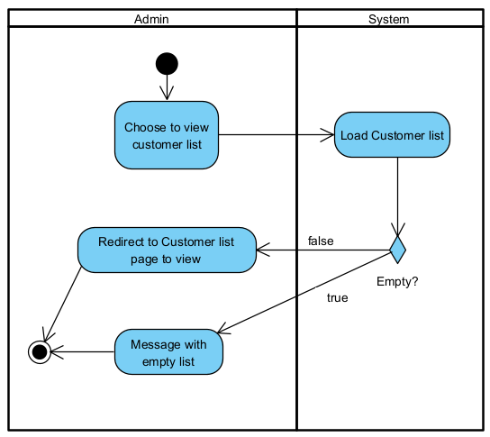

#### Sequence diagram

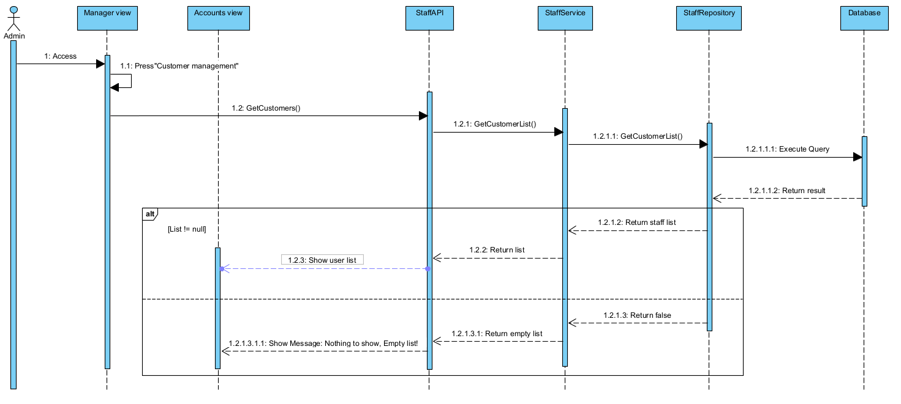

### View Staff Account list:

| ID and Name: | UC13 - View Staff Account List | | |
| --- | --- | --- | --- |
| Created By: | TeamDev | Date Created: | 30/06/2023 |
| Primary Actor: | Admin | Secondary Actors: | FC |
| Description: | This feature allows Admin to view Staff Account list | | |
| Trigger: | Admin indicates that he wants to view Staff account list in his showroom | | |
| Preconditions: | User has logged in successfully  User access in Manager page | | |
| Postconditions: | N/A | | |
| Normal Flow: | 1. User tap on "Staff management" in the Manager page  2. System displays Staff account list | | |
| Alternative Flows: | N/A | | |
| Exceptions: | Admin want to see Account list but it is empty or can not be show | | |
| Priority: | Low | | |
| Frequency of Use: | Usually | | |
| Business Rules: | N/A | | |
| Other Information: | N/A | | |
| Assumptions: | N/A | | |

* Function trigger: After admin click link manager user
* Function description: This page allow admin to seen all user
* Screen layout:
* Function detail: user must login with admin role before do this action to see staff list

#### Activity diagram

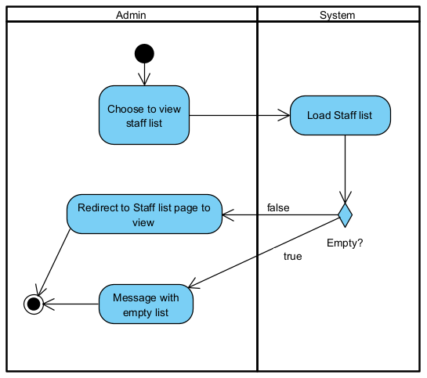

#### Sequence diagram

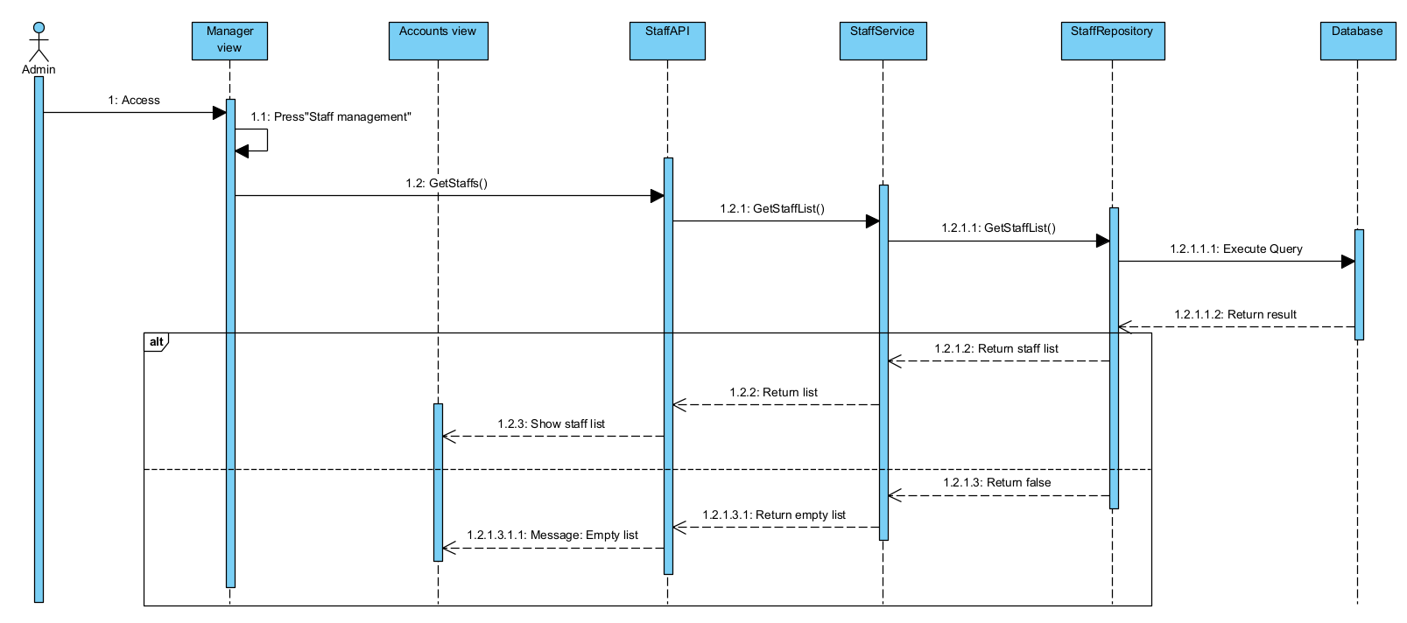

### Change status

| ID and Name: | UC14 - Change staff account status | | |
| --- | --- | --- | --- |
| Created By: | TeamDev | Date Created: | 30/06/2023 |
| Primary Actor: | Admin | Secondary Actors: | FC |
| Description: | This feature allows Admin to set status for an account | | |
| Trigger: | Admin indicates that he wants to change status for some account | | |
| Preconditions: | User has logged in successfully  User have a list of account showing in Manager page | | |
| Postconditions: |  | | |
| Normal Flow: | Admin tap on an Account’s “Change Status” button  Admin choose to Activate or Deactivate  Account status then get saved | | |
| Alternative Flows: | N/A | | |
| Exceptions: | N/A | | |
| Priority: | Low | | |
| Frequency of Use: | Usually | | |
| Business Rules: | N/A | | |
| Other Information: | N/A | | |
| Assumptions: | N/A | | |

* Function trigger: After admin click link manager user and click change status button
* Function description: This page allow admin to change status all user
* Screen layout:
* Function detail: User must login with admin role before do this action to change status customer or staff

#### Activity diagram

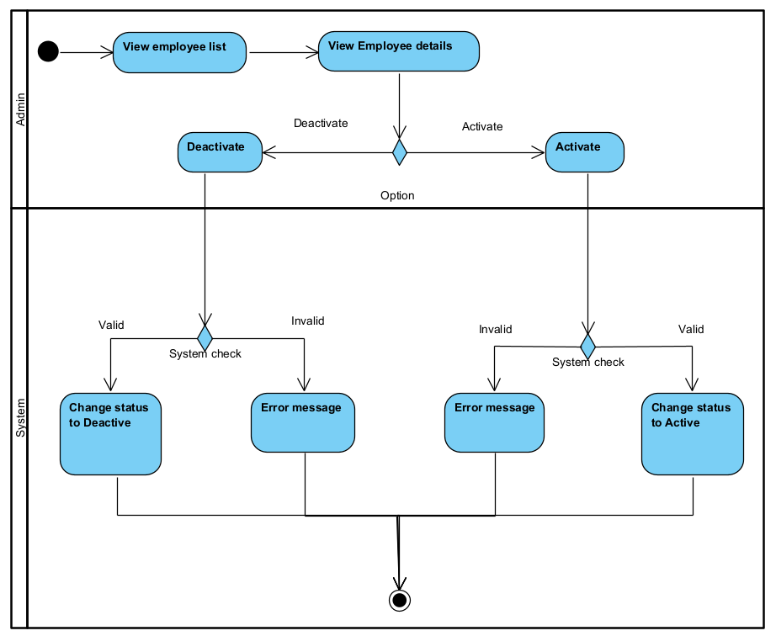

#### Sequence diagram

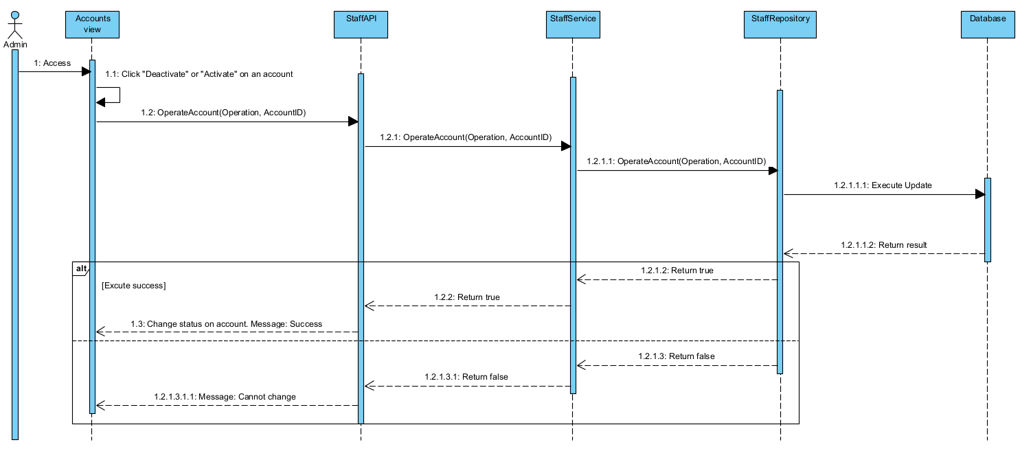

## **5. Profile**

### Show profile

| ID and Name: | UC15 - View Profile | | |
| --- | --- | --- | --- |
| Created By: | TeamDev | Date Created: | 30/06/2023 |
| Primary Actor: | Authorised User | Secondary Actors: | Admin |
| Description: | This feature allows user to view their profile | | |
| Trigger: | Member indicates that he/she wants to view their profile | | |
| Preconditions: | User has logged in successfully | | |
| Postconditions: | N/A | | |
| Normal Flow: | 1. User tap on "Profile" icon in the navigation bar  2. System displays logged in user’s profile | | |
| Alternative Flows: | N/A | | |
| Exceptions: | N/A | | |
| Priority: | Low | | |
| Frequency of Use: | Usually | | |
| Business Rules: | N/A | | |
| Other Information: | N/A | | |
| Assumptions: | N/A | | |

* Function trigger: After user click link profile user
* Function description: This page allow user to seen their profile
* Screen layout:
* Function detail: user must login with customer or staff role before do this action to see profile of customer or staff

#### Activity diagram

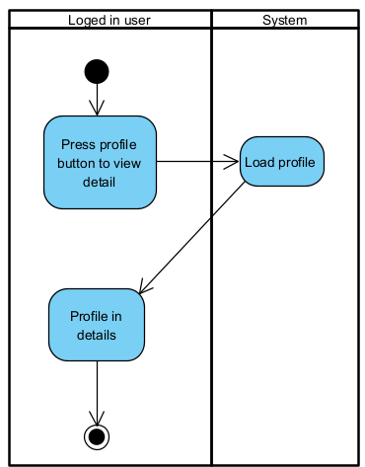

#### Sequence diagram

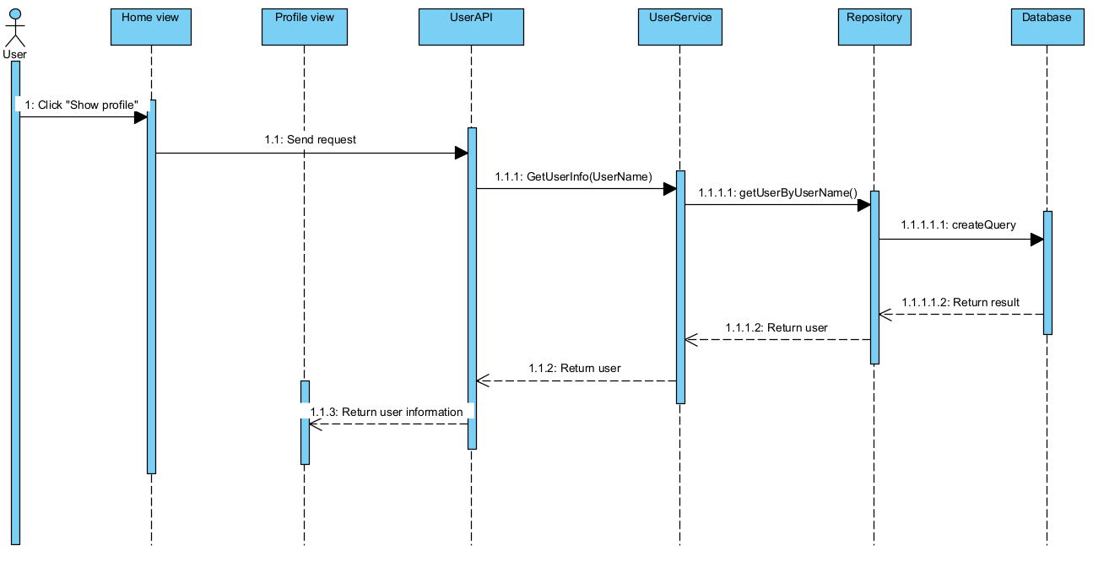

### **Update profile**

| ID and Name: | UC16 - Update Profile | | |
| --- | --- | --- | --- |
| Created By: | TeamDev | Date Created: | 30/06/2023 |
| Primary Actor: | Authorised user | Secondary Actors: | N/A |
| Description: | This feature allows user to edit their profile | | |
| Trigger: | Member indicates that they want to edit their profile | | |
| Preconditions: | User has logged in successfully  User must be on the “Profile” screen | | |
| Postconditions: | New user profile is updated in the system | | |
| Normal Flow: | 1. User clicks on “Update profile” button  2. System displays “Update profile” screen  3. User inputs information into required fields and clicks “Save”or “Cancel” button  4. User choose Yes/No in pop-up  5. System displays result message | | |
| Alternative Flows: | N/A | | |
| Exceptions: | User escape Update Profile screen before select “Save/Cancel”  User fill invalid information | | |
| Priority: | Low | | |
| Frequency of Use: | Usually | | |
| Business Rules: | N/A | | |
| Other Information: | N/A | | |
| Assumptions: | N/A | | |

* Function trigger: After customer or staff click link profile user
* Function description: This page allow customer or staff to update their profile
* Screen layout:
* Function detail: user must login with customer or staff role before do this action to update customer or staff profile

#### Activity diagram

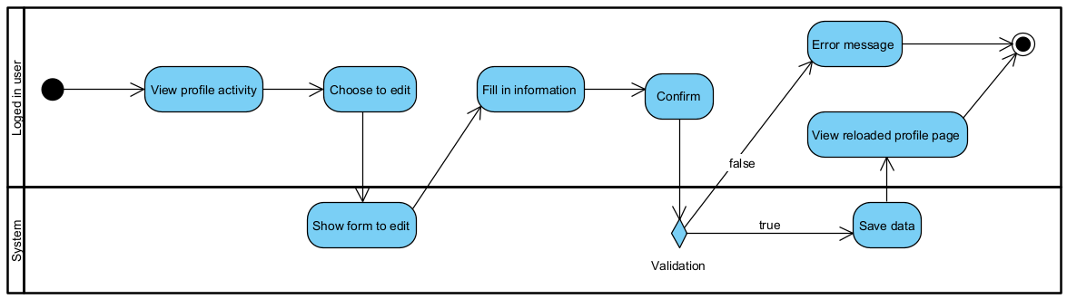

#### Sequence diagram

## **6. Order**

### **Order History**

| ID and Name: | UC17 - View Order History | | |
| --- | --- | --- | --- |
| Created By: | TeamDev | Date Created: | 30/06/2023 |
| Primary Actor: | Authorised User | Secondary Actors: | FC |
| Description: | This feature allows customer to view their order history | | |
| Trigger: | User indicates that he wants to view his order history | | |
| Preconditions: | User has logged in successfully | | |
| Postconditions: |  | | |
| Normal Flow: | 1. User tap on "Order" icon in the navigation bar  2. System displays order history | | |
| Alternative Flows: | N/A | | |
| Exceptions: | User get to see order history but it is empty | | |
| Priority: | High | | |
| Frequency of Use: | Usually | | |
| Business Rules: | N/A | | |
| Other Information: | N/A | | |
| Assumptions: | N/A | | |

* Function trigger: After customer click link order history
* Function description: This page allow customer or staff to seen all order of customer
* Screen layout:
* Function detail: user must login with customer or staff role before do this action to see history order

#### Activity diagram

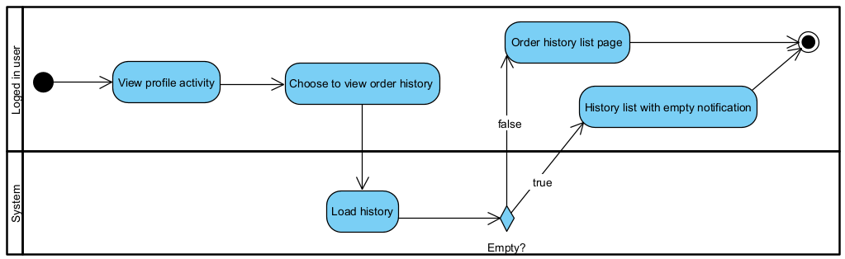

#### Sequence diagram

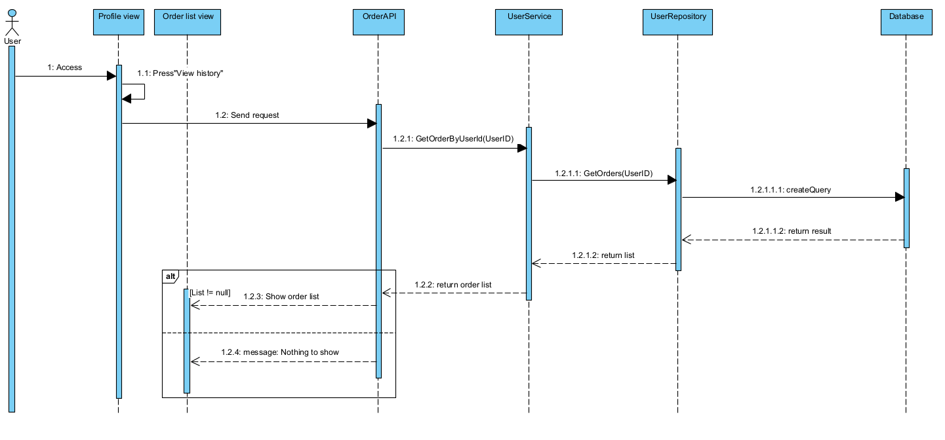

### **Order detail**

| ID and Name: | UC 18 - View Order Detail | | |
| --- | --- | --- | --- |
| Created By: | TeamDev | Date Created: | 30/06/2023 |
| Primary Actor: | Authorised User | Secondary Actors: | FC |
| Description: | This feature allows user to edit their profile | | |
| Trigger: | Member indicates that they want to edit their profile | | |
| Preconditions: | User has logged in successfully  User must be on the “Profile” screen | | |
| Postconditions: | New user profile is updated in the system | | |
| Normal Flow: | User access into order history  User clicks on one specific order  System show detail in that order | | |
| Alternative Flows: | N/A | | |
| Exceptions: | N/A | | |
| Priority: | Low | | |
| Frequency of Use: | Usually | | |
| Business Rules: | N/A | | |
| Other Information: | N/A | | |
| Assumptions: | N/A | | |

* Function trigger: After customer or staff click button view per order into order table
* Function description: This page allow admin to seen all user
* Screen layout:
* Function detail: user must login with customer or staff role before do this action to see order detail of customer’s order

#### Activity diagram

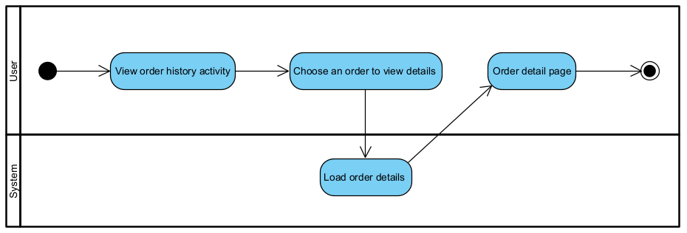

#### Sequence diagram

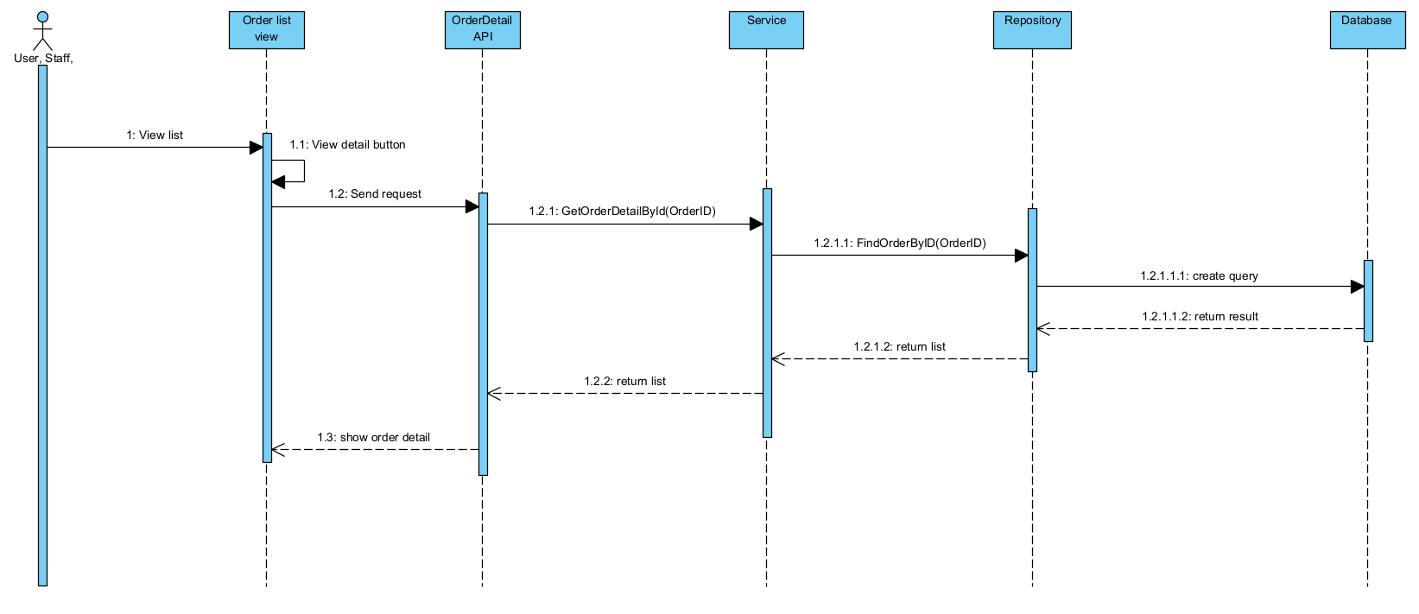

### **Proceed order for staff**

| ID and Name: | UC15 - Proceed Order | | |
| --- | --- | --- | --- |
| Created By: | TeamDev | Date Created: | 30/06/2023 |
| Primary Actor: | Staff | Secondary Actors: | FC |
| Description: | This feature allows staff to view order and proceed it | | |
| Trigger: | Staff choose an order to view and proceed it | | |
| Preconditions: | User has logged in successfully | | |
| Postconditions: | Order status saved in suitable one | | |
| Normal Flow: | Staff choose an order to proceed  Staff then contact customer to confirm order  Staff then change order status to confirmed or cancel it due to customer decision | | |
| Alternative Flows: | Staff view to see that order can not be performed then contact customer  1.2 Customer then decide to get order wait  1.3 Staff confirm and leave order to proceed later  1.4 Staff then confirm Admin to add more product  2.1 Customer then decide to cancel order  2.2 Staff cancel order | | |
| Exceptions: | N/A | | |
| Priority: | High | | |
| Frequency of Use: | Usually | | |
| Business Rules: | N/A | | |
| Other Information: | N/A | | |
| Assumptions: | N/A | | |

#### Activity diagram

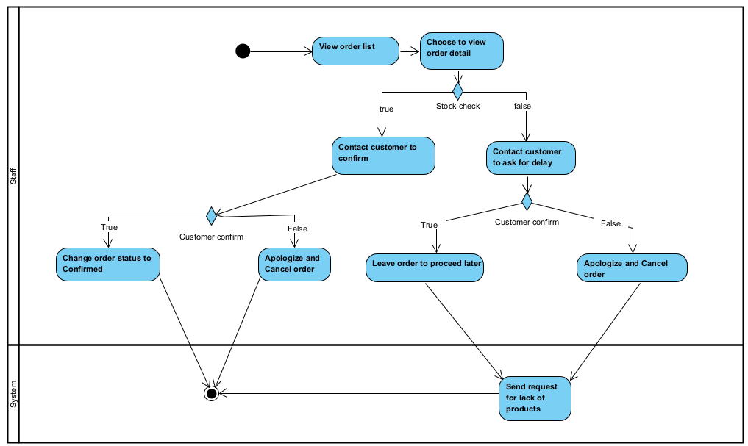

#### Sequence diagram

N/A

# **III. Database**

## **1. ERD**

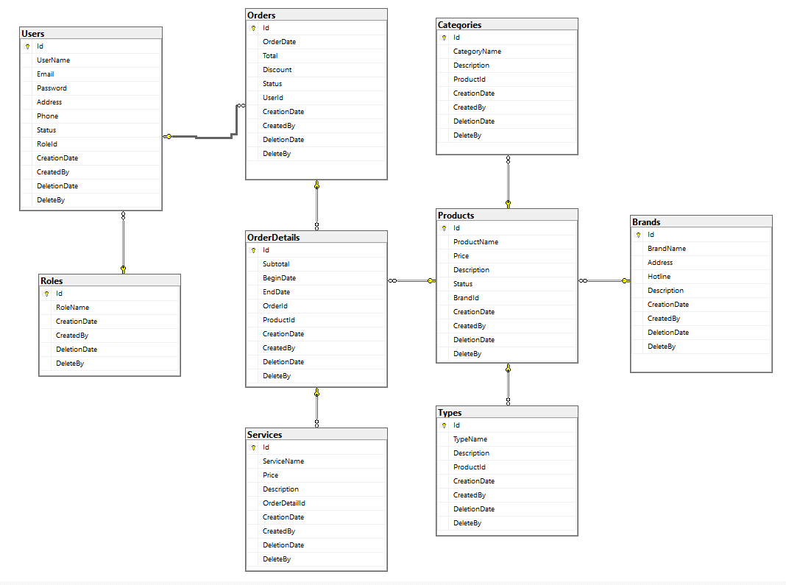

## **2. Database table**

***Table descriptions & package class naming conventions are as below***

| **No** | **Table** | **Description** |
| --- | --- | --- |
| 01 | Role | This table include role name such as: admin, customer, staff  - Primary keys: ID  - Foreign keys: Non |
| 02 | User | This table include information user  - Primary keys: ID  - Foreign keys: IdRole |
| 03 | Order | This table include information order of user  - Primary keys: ID  - Foreign keys: UserId |
| 04 | Order detail | This table include information detail each order  - Primary keys: Non  - Foreign keys: OrderId, ProductId |
| 05 | Product | This table include information each product  - Primary keys: ID  - Foreign keys:BrandId |
| 06 | Service | This table includes information about each service such as: clean,...  - Primary keys: ID  - Foreign keys: OrderDetailId |
| 07 | Type | This table classification of motorcycles or accessories  - Primary keys: ID  - Foreign keys: ProductId |
| 08 | Brand | This table detailed car brand  - Primary keys: ID  - Foreign keys: non |
| 09 | Category | This table classification of Car level: A, B,...  - Primary keys: ID  - Foreign keys: ProductId |